Midterm Project

Task 3.1

**Get Familar with Sql commands:**

As this task was to apply different queries and get the employee’ table open in the terminal. So, what I did I open the database that was already created in the container. First I find the container MySQL and then I wrote the following given command ‘mysql-u root -p’ to open the database in the terminal

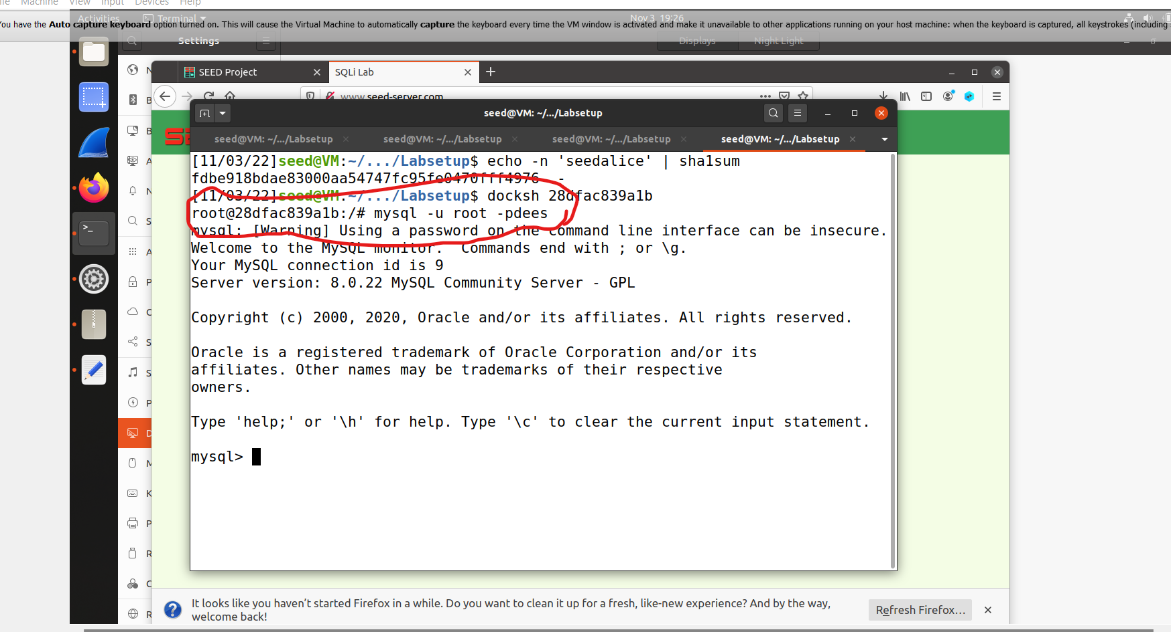

Then open the all the databases to reach the required database.

The query I applied to see all the databases is ‘show databases;’

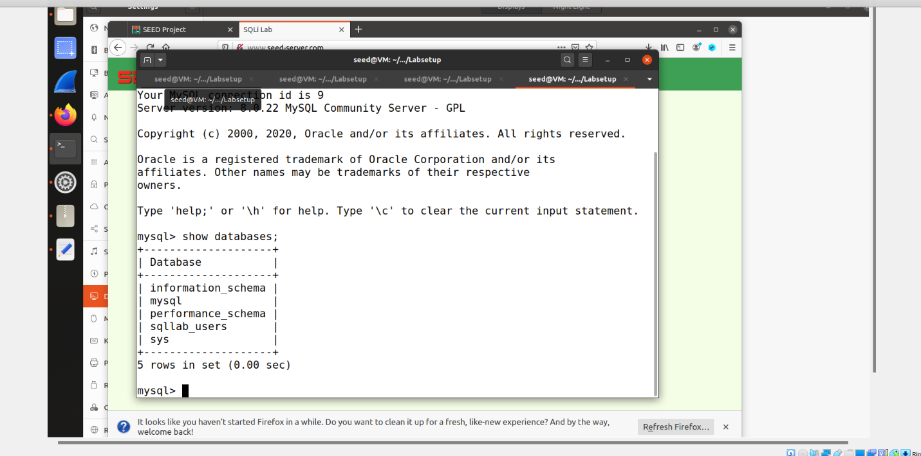

In this picture we can see all the databases and sqllab_users that required us to open in our terminal in next step we will open it through the query.

I get the access to sqllab_users through use sqllab_users; query

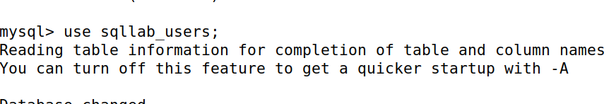

As I was able to access the sqllab database next step was to check the required tables in this database and information within the tables by applying different queries

First, I showed all the tables of the database. So, I apply the query show tables; and only one table was existed by the name of credential that pop up when I pressed enter after writing the query. Here is the screen shot of the table credential

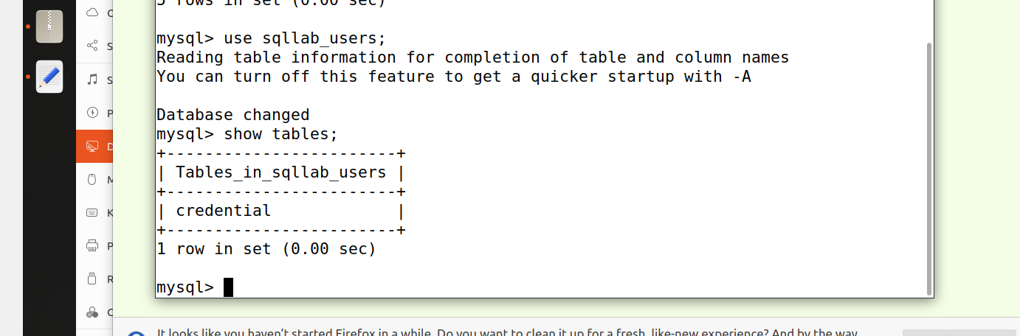

Here how the schema of the table is look like by applying query

describe credentials.

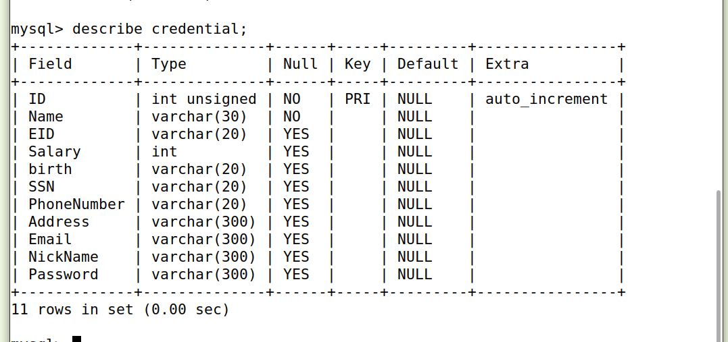

I apply query Select * from credentials.

It shows me the all the information of the table. This table contain the data of the employee with their personal information, employee’s Id and the hashing password of each employee was stored there. You can clearly see in the picture below the users’ id and their personal information

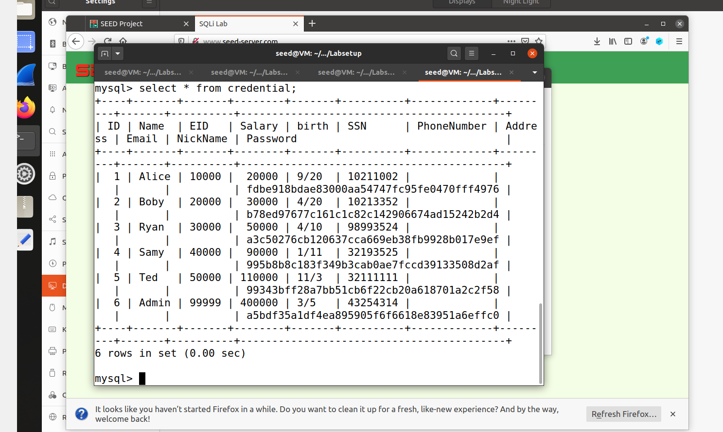

**3.2 Task 2: SQL Injection Attack on SELECT Statement**

In this task I first open the unsafe_home.php file. As I have to login as attacker without knowing the employee ’credential so make some changes to this php file so I can easily login to the web application to see the information of employee.

**2.1 Task: - To** achieve this task , I modify the source code in the unsafe_home.php file outside the container and I added this piece of code echo $sql so I can access the employee’ account as an attacker. This piece of code will make the user’s account pop without knowing their credentials

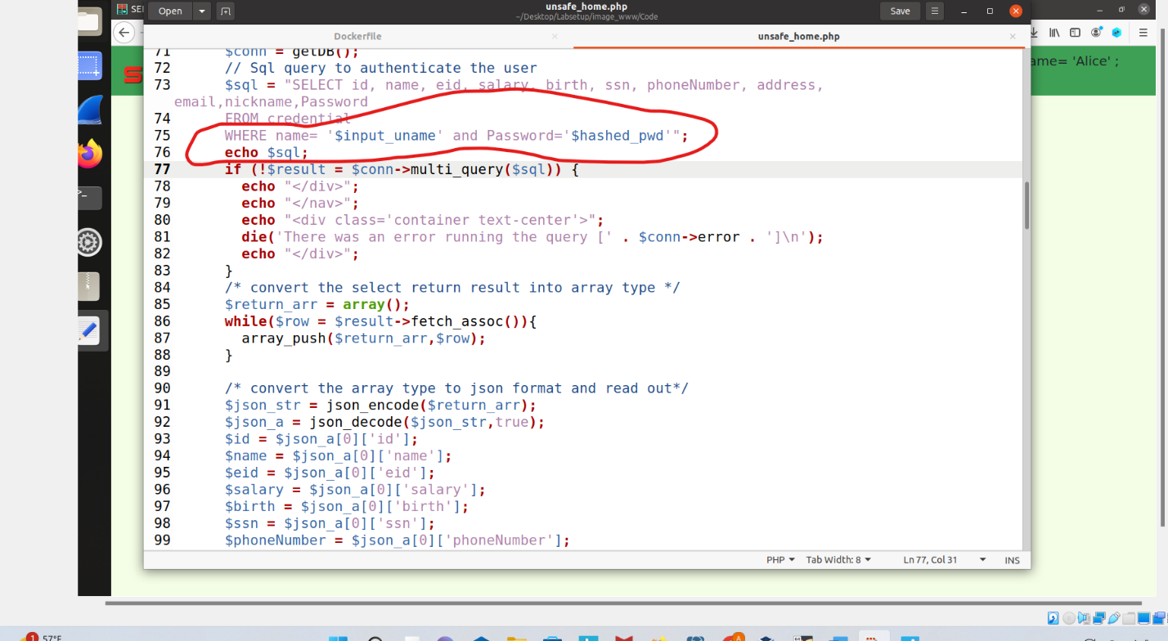

In the next step I will login in admin account without password.

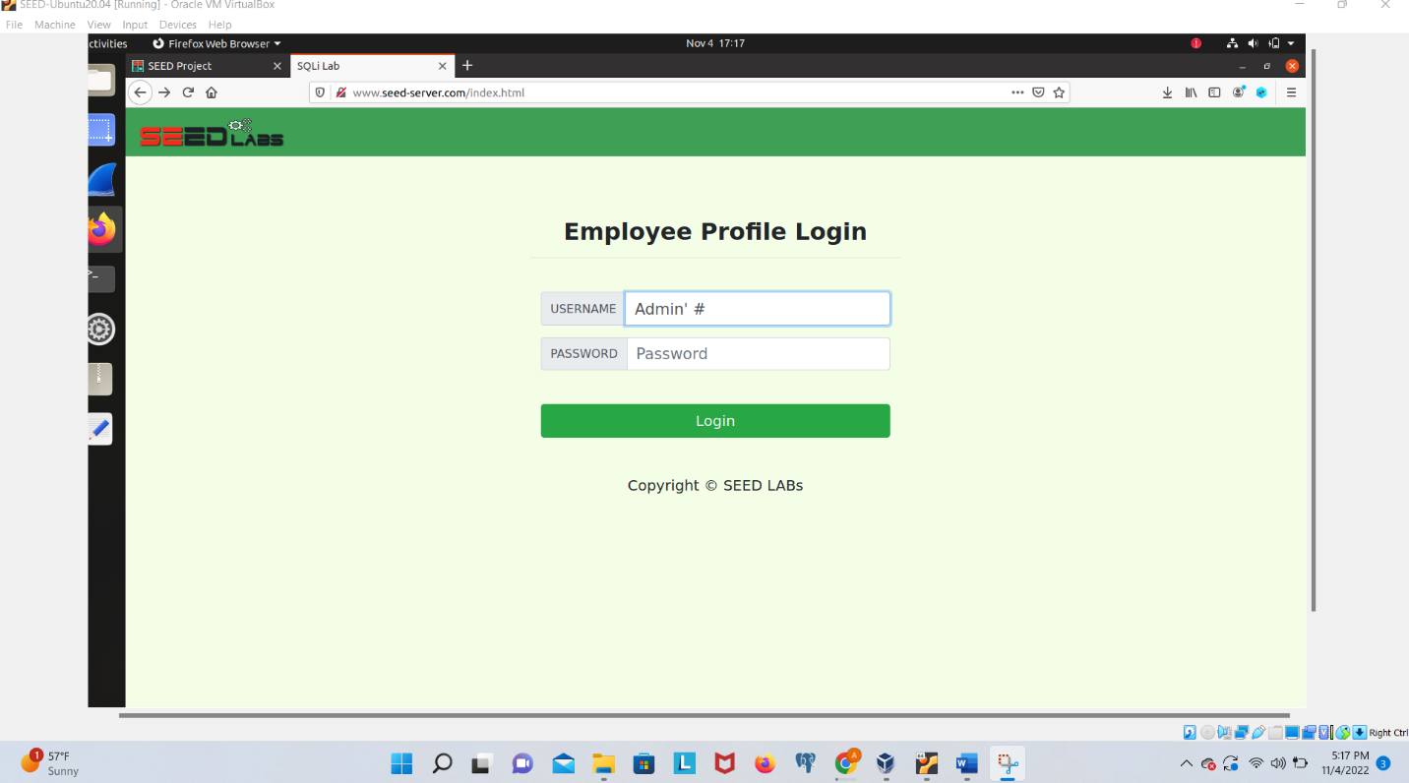

Here is the output you can see that we put just Amin’ # it takes us to the admin profile and show us all the users with their information. On the top side we can clearly see the admin’s data.

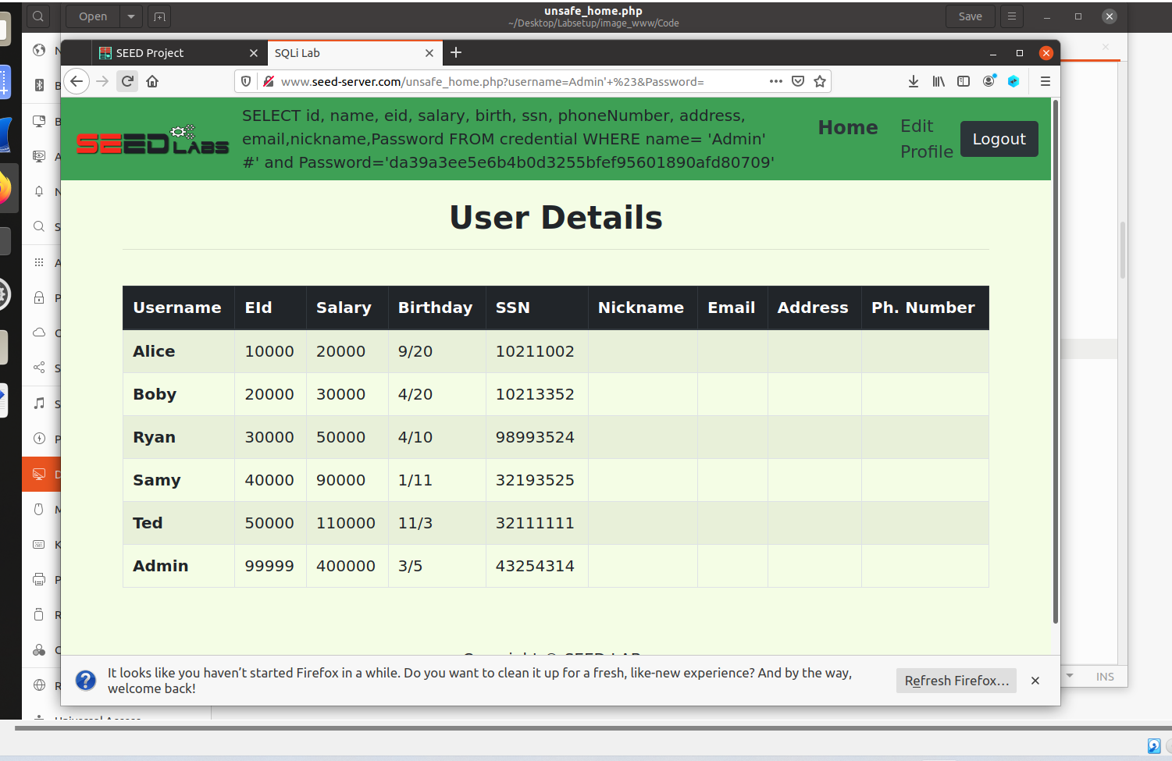

**Task 2.2: SQL Injection Attack from command line**

In this task we will make attack by using the command line we are given for this task which will send an HTTP request to perform the attack.Here is the command line that we will encode in the URL

curl ’www.seed-server.com/unsafe_home.php?username=alice&Password=11’

I make some changes in this command like instead # key I use %27 to make our attack successful.

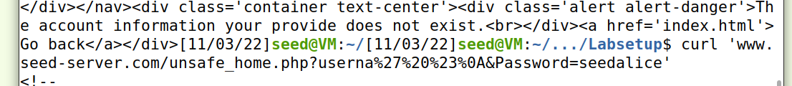

Here what result I got after this query, and it will show us the hash password of the user and other information of the user.

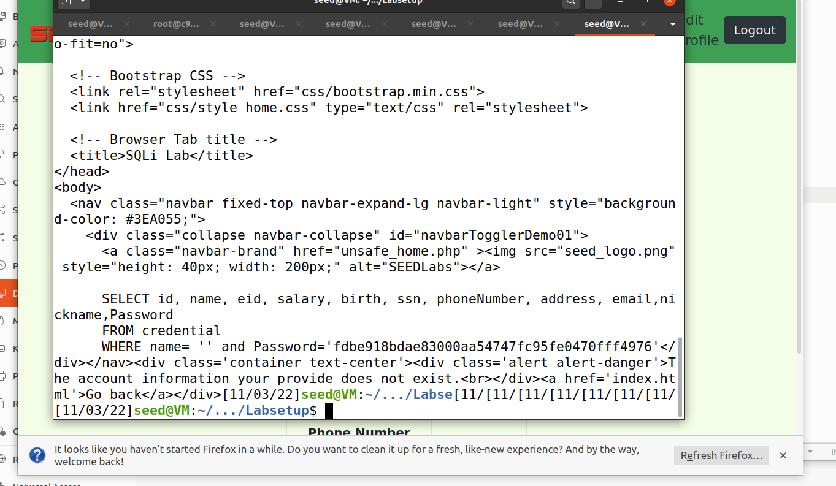

**Task 2.3: Append a new SQL statement.**

I modify the unsafe_hom.php I add some new stuff to this file so I can reach the exact goal

Here what I write new code for this task

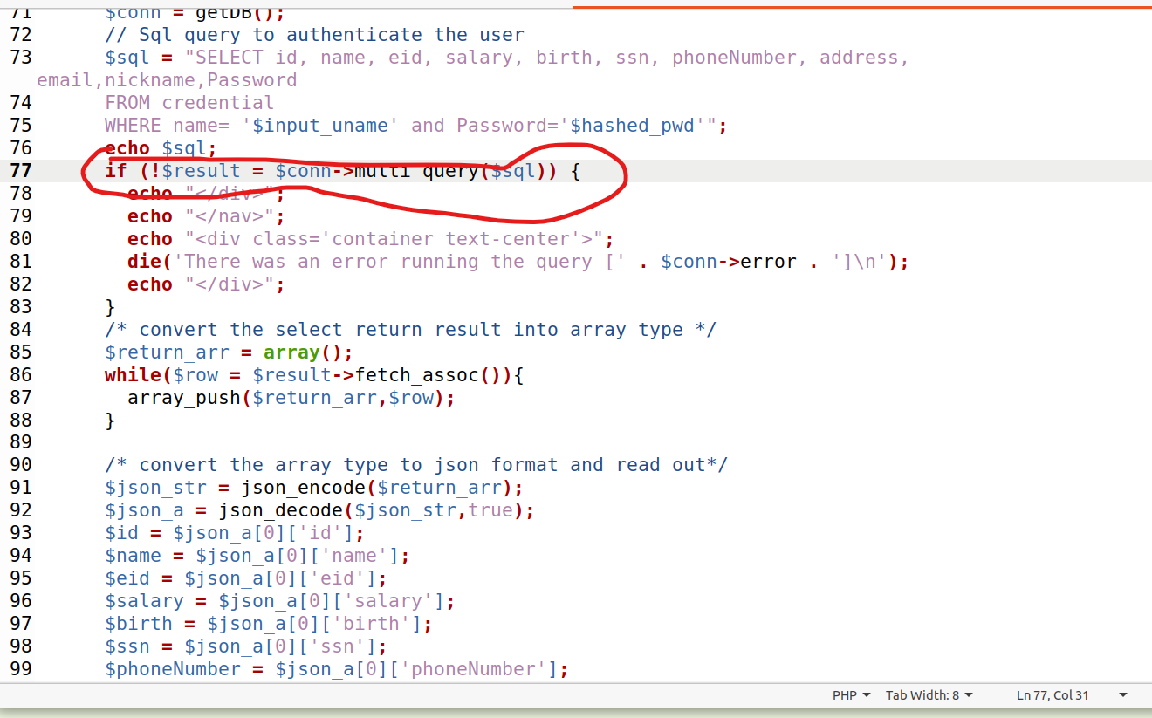

Here How I login for this task

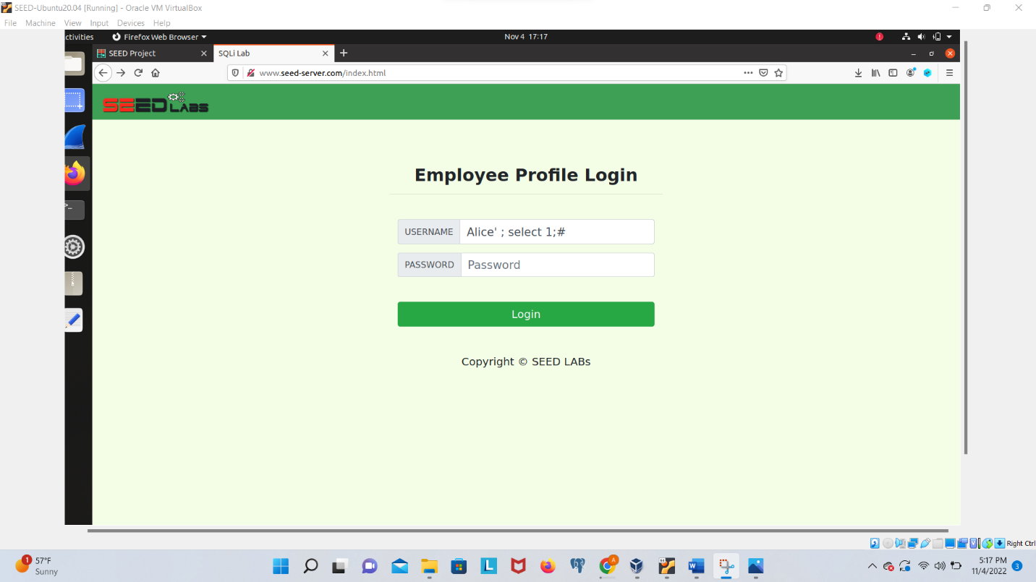

And When I login the output of task is here’

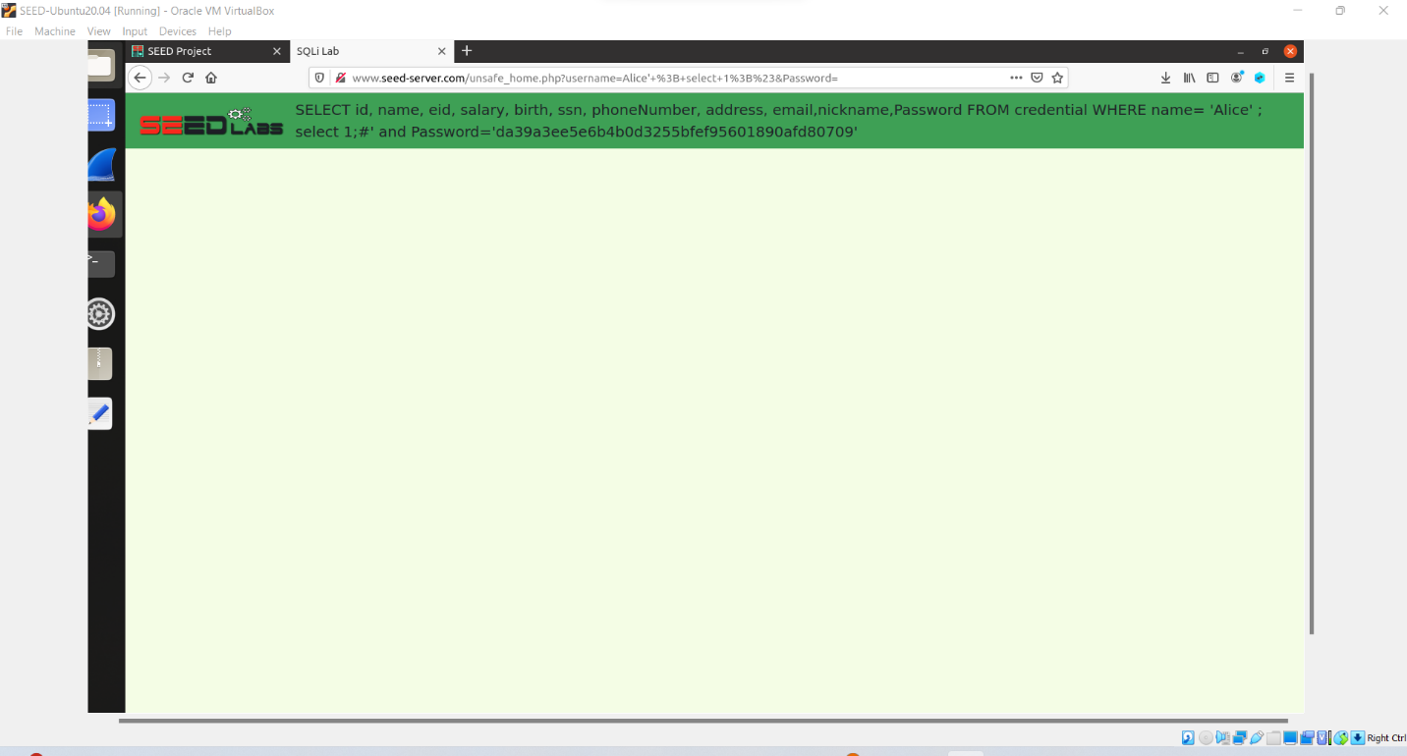

**Task 3: SQL Injection Attack on UPDATE Statement**

If a SQL injection vulnerability happens to an UPDATE statement, the damage will be more severe, because attackers can use the vulnerability to modify databases. In our Employee Management application, there is an Edit Profile page (Figure 2) that allows employees to update their profile information, including nickname, email, address, phone number, and password. To go to this page, employees need to log in first.

For this section of the lab, we want to change the employee’s salary since employees are not authorized to change it themselves. The first step to figuring out how to inject this attack is by using what is given to us. We can start off by simply editing the employees’ profile and viewing the changes on the user interface as well as the changes in the database.

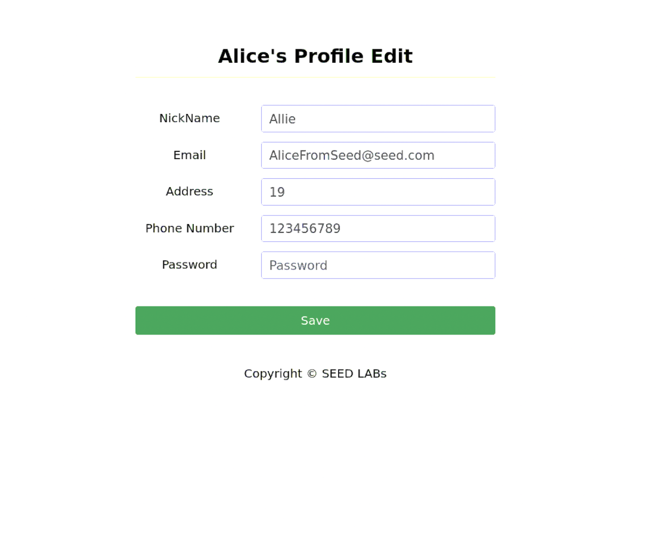

We enter the information to update the profile.

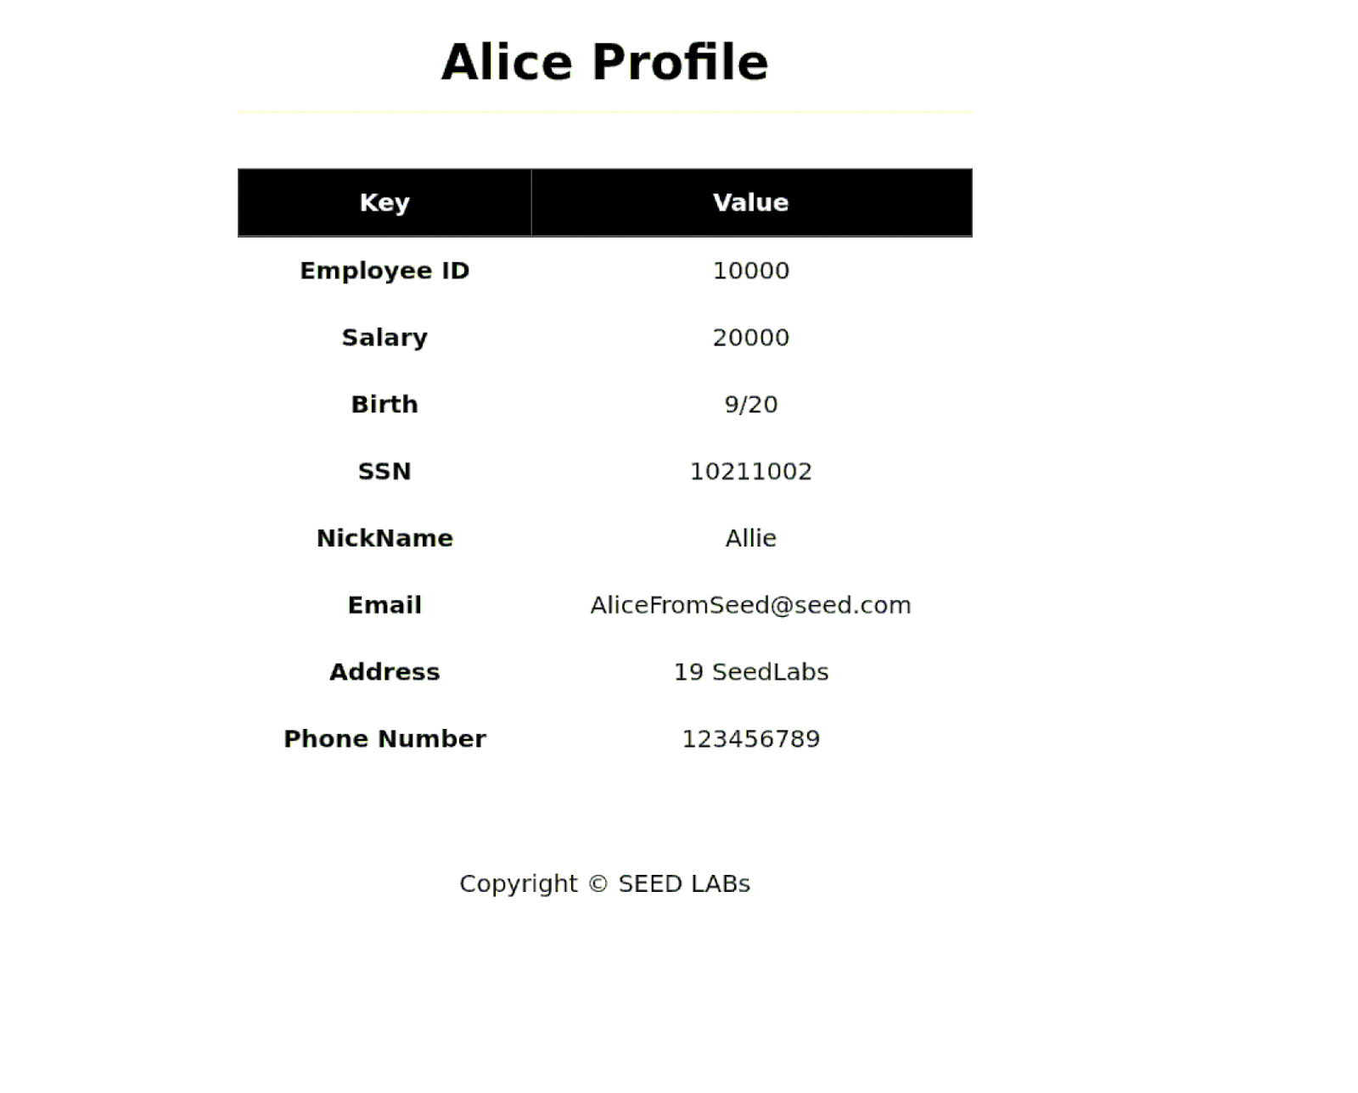

Now we check to see the changes in the database.

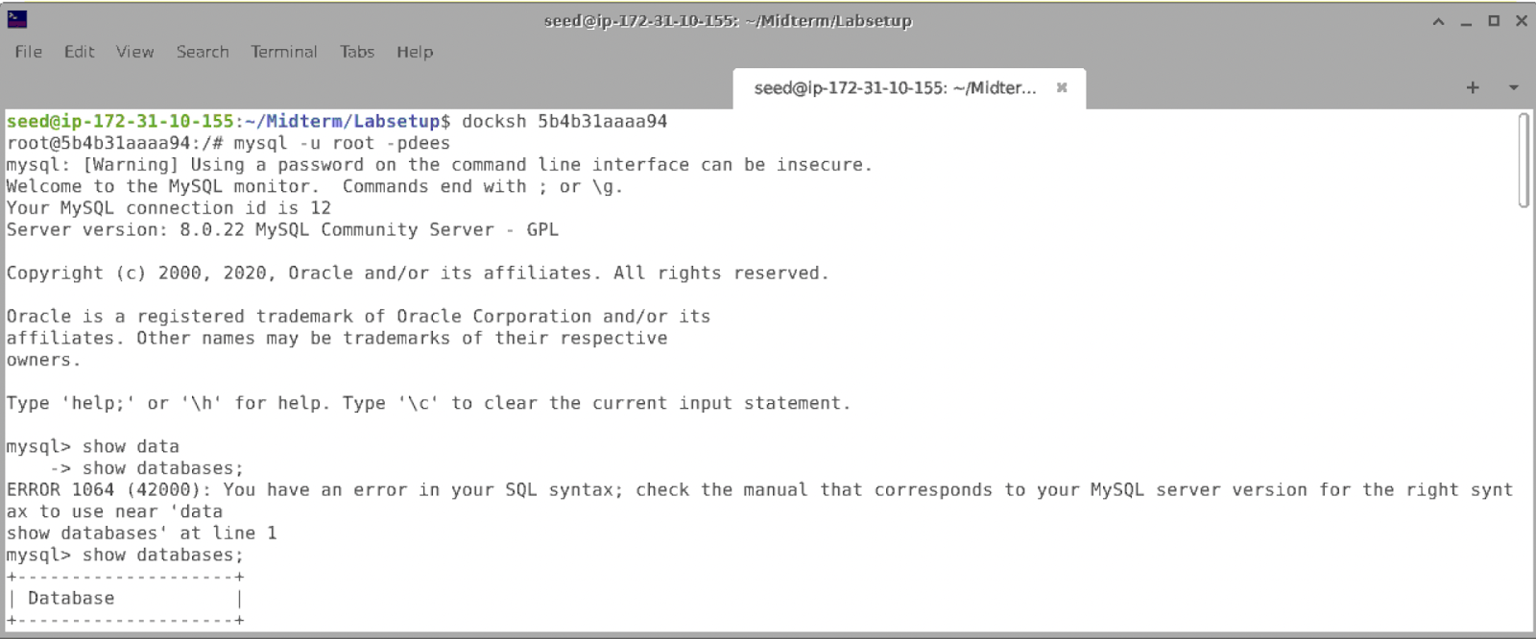

We run dockps and grab the container id and use docksh to use it as a root. Then we can run our sql commands here and grab database information.

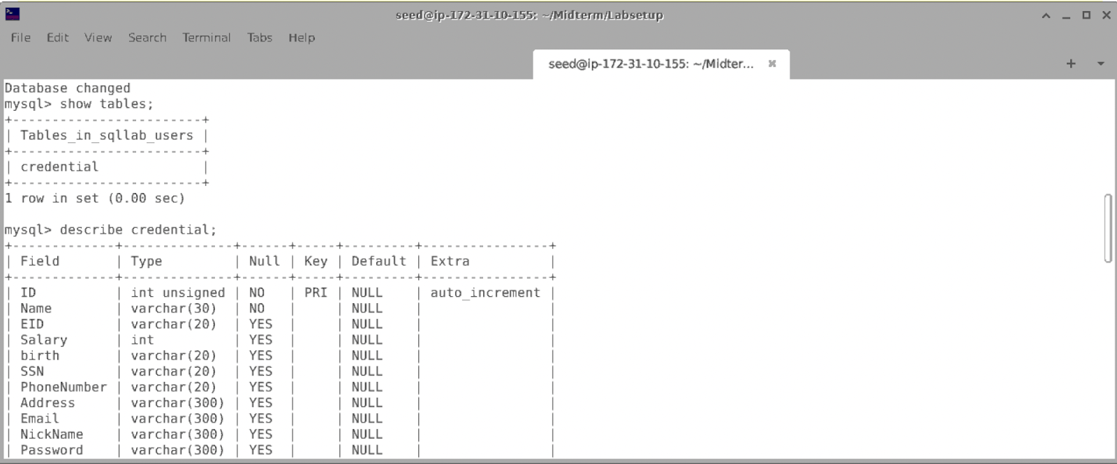

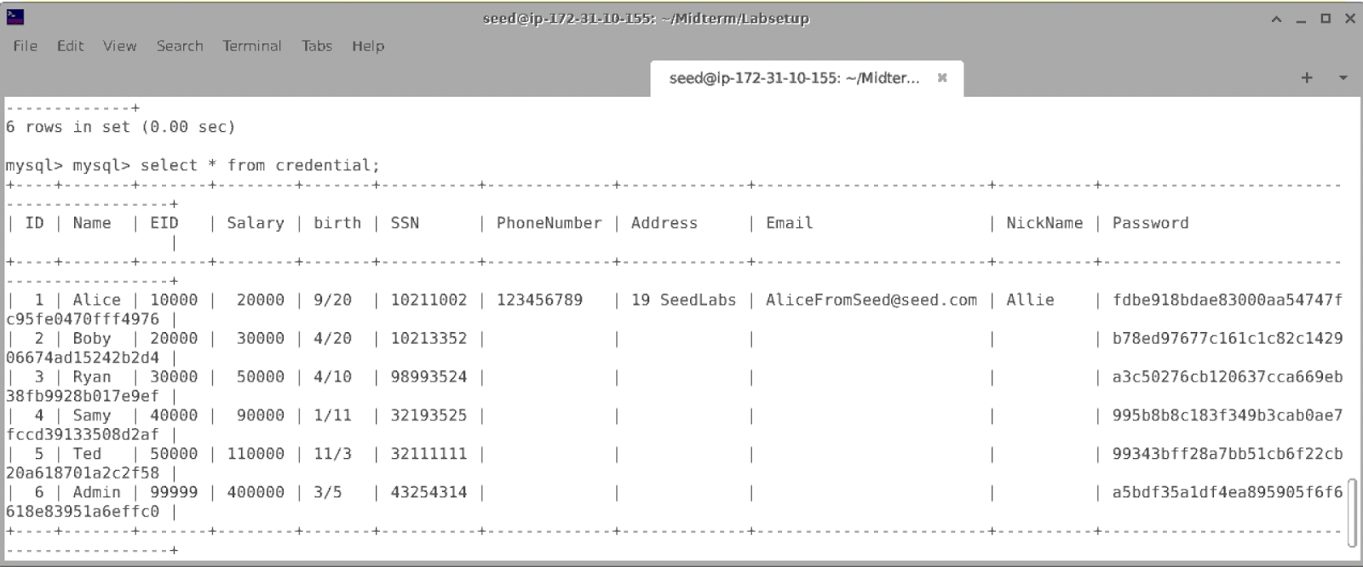

We see that the changes we made from the edit profile page also modified the information in the database.

**Task 3.1: Modify your own salary.**

As shown in the Edit Profile page, employees can only update their nicknames, emails, addresses, phone numbers, and passwords; they are not authorized to change their salaries. Assume that you (Alice) are a disgruntled employee, and your boss Boby did not increase your salary this year. You want to increase your own salary by exploiting the SQL injection vulnerability in the Edit-Profile page. Please demonstrate how you can achieve that. We assume that you do know that salaries are stored in a column called salary.

Alice is frustrated that she has been working so hard over the years and her boss has not given her a raise yet. She wants to take matters into her own hands and change her salary by SQL injection. We know that Alice is not authorized to change her salary. Alice looks at the PHP file which is used to update employee’s profile information. She enters the unsafe edit backend.php file and looks through the code.

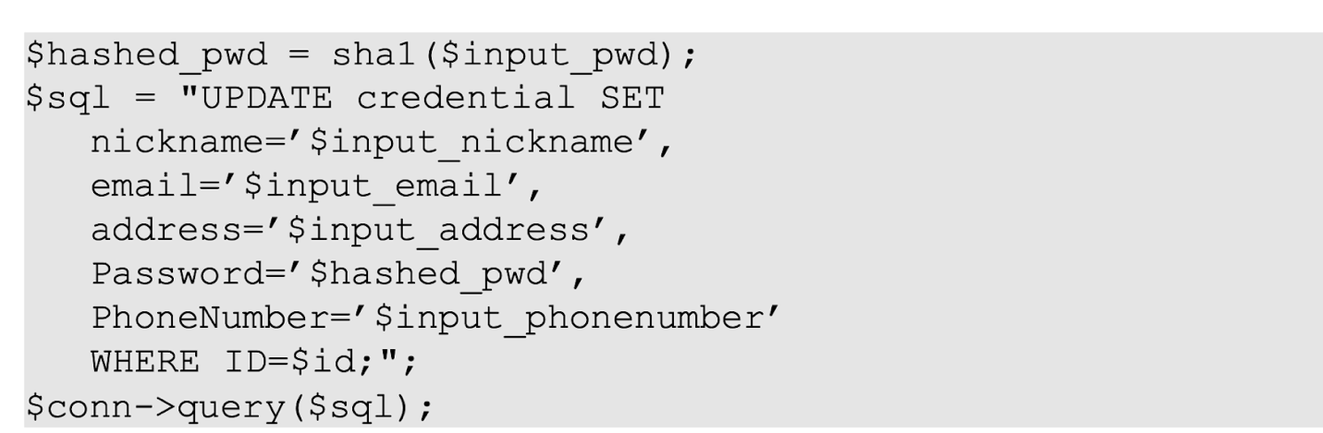

We know that the salaries of the employees are stored in a column called salary. Now, using the edit profile page from before, we can utilize the nickname section to change Alice’s salary just like she wants to. We also do not want to exploit any information about who changed the salary and how it was changed. We do not want the following changes to be modified for the other employees, so we use where name = ‘Alice’ to specify the specific employee. We also do not want to modify the other categories, so we comment it out using a #.

We enter the following query in the nickname textbox, ', salary=500000 where name= 'Alice' #

This changes the salary as intended for Alice and comments out the other areas. We save the changes and we can see that the Salary has successfully changed on Alice’s profile.

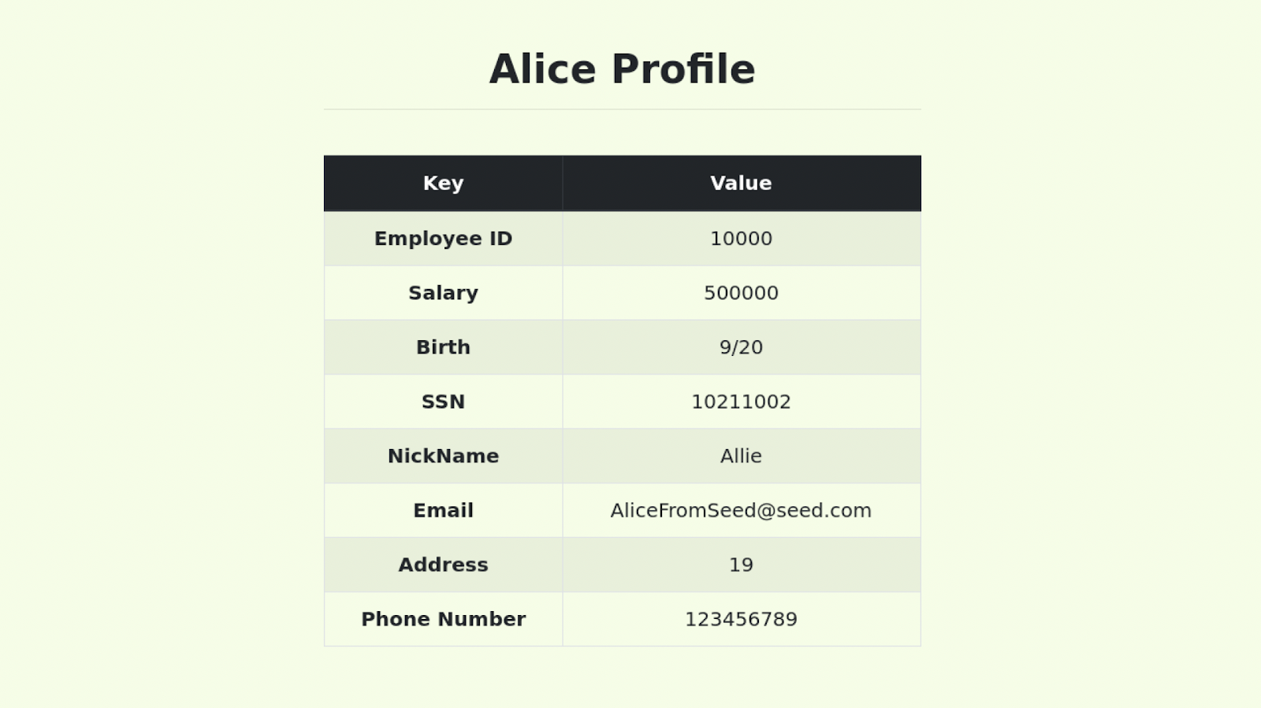

We can also view the changes for the salary in the database.

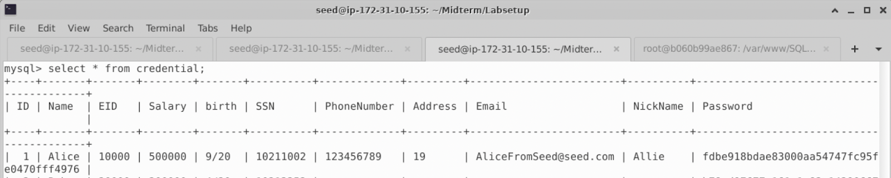

**Task 3.2: Modify other people’ salary.**

After increasing your own salary, you decide to punish your boss, Boby. You want to reduce his salary to 1 dollar. Please demonstrate how you can achieve that.

Alice is still not content with just raising her salary. She wants to punish her boss, Boby as well and change his salary to just $1. Alice does not have access to her boss’s account and must inject a SQL attack through her own profile.

We can initiate the same SQL injection that we used to raise Alice’s salary but, instead we would fill in the values for Boby. We also do not want to modify the other employees since they have done nothing wrong to Alice. There are multiple values that we can use in this case because we know the same values that are given for Alice are also given for the other employees and her boss. Her boss also has credentials for his name, ID, salary, etc. To keep it simple and straightforward, I will change the Salary to 1 and I will use the name value to apply the changes to Boby’s account. Using the nickname textbox from Alice’s profile edit page, we insert Boby’s value for name and for salary we replace it with 1.

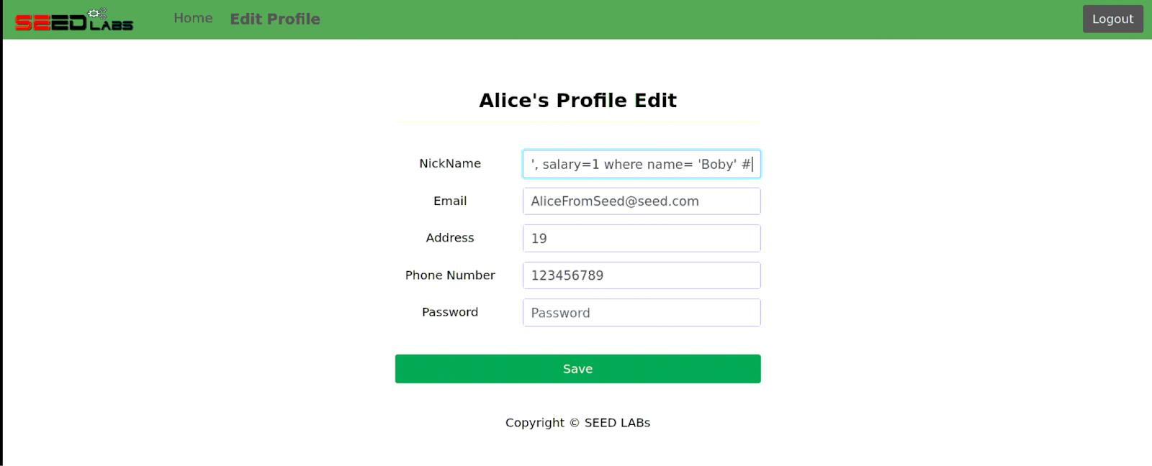

', salary=1 where name= 'Boby' # // we leave the nickname as an empty string since we dont want anything else but the salary to be modified

We can also use the value ID and other credentials in place for names to make this attack go through. For example, it can be', salary=1 where ID= '2' #, we can find the values from the database credentials table.

We proceed to save the changes and we can see that Alice’s profile does not have any changes which is a good sign because we do not want to affect anyone else’s account but Boby’s.

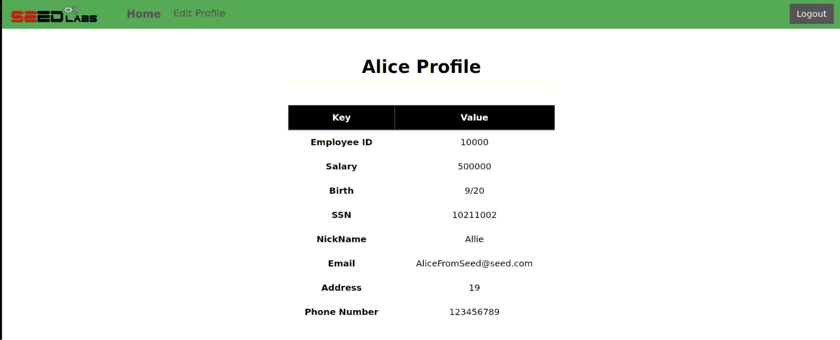

Now, we check the database table for credentials, and we should see that Boby’s salary has changed to 1. If this is the case, Alice has successfully injected her attack.

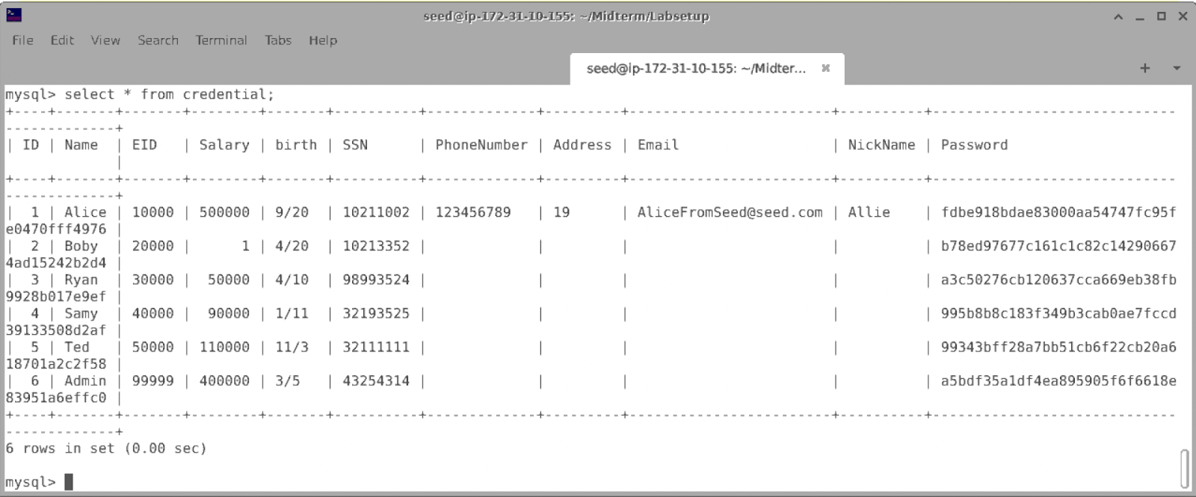

From these changes we can also tell that these changes have also changed Boby’s salary amount on his profile.

**Task 3.3: Modify other people’ password.**

After changing Boby’s salary, you are still disgruntled, so you want to change Boby’s password to something that you know, and then you can log into his account and do further damage. Please demonstrate how you can achieve that. You need to demonstrate that you can successfully log into Boby’s account using the new password. One thing worth mentioning here is that the database stores the hash value of passwords instead of the plaintext password string. You can again look at the unsafe edit backend.php code to see how password is being stored. It uses SHA1 hash function to generate the hash value of password.

Alice wants to take it a step further and hack into her boss’s account. But she doesn't know his password for his account. What she does know is his username. We can gather more information from the database. We see that Boby’s username is Boby since that is what’s under the Name value. We can also view the password, but it is encrypted in random hashed letters and numbers.

The current password that Boby has is b78ed97677c161c1c82c142906674ad15242b2d4

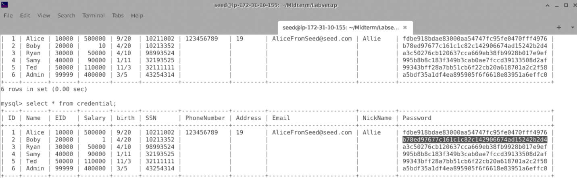

We want to change the password string so we can log into Boby’s account. We do this by using the same method we used for the previous attacks. We enter our sql injection attack once again in Alice’s nickname textbox. We know that the database stores the hash value of passwords instead of the plain text string that we set. Within the text box we insert the following sql query,

', password=sha1('hack1') where name= 'Boby' #

We use the same query but instead of salary, we place the password value and enter the password we want to set for Boby’s account. We give the password the values of sha1 which represents the hash function that is used to generate the hash value of the password and within the sha1 function, we enter the password that we want to set. I chose hack1 to be the password. We want the changes to be updated for Boby so we use his name for the name value.  We save our changes and proceed.

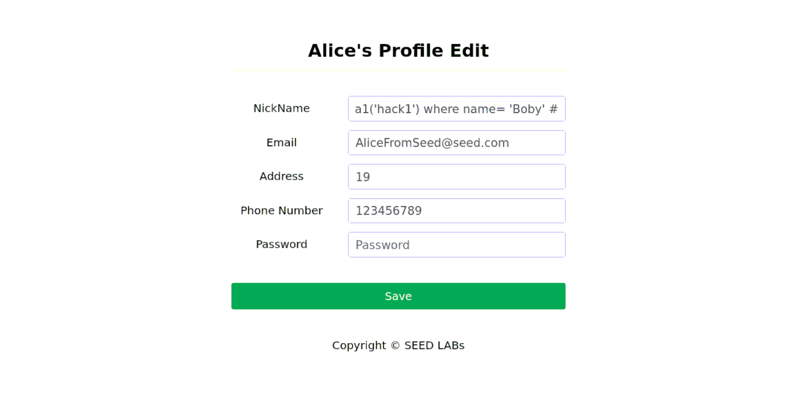

 We now check the database to see if our changes went through. We check the password category from the credentials table, and we see that the password has a different value from the initial one.

c42e075a59ee28a699ef0a337a511a721acacdc5

This tells us that the password has successfully changed to the one we wanted.

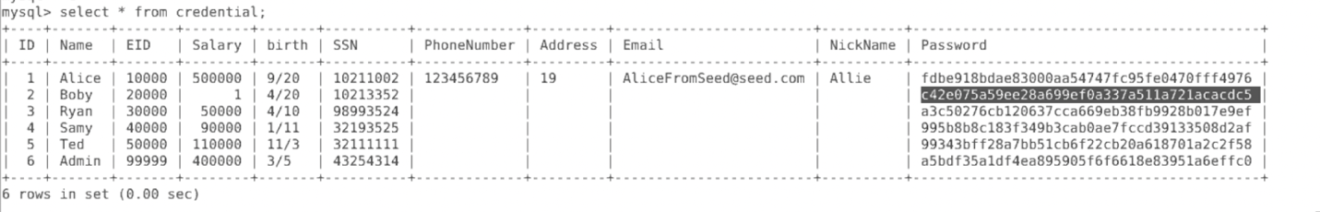

Now, we log out of Alice’s account and log in to Boby’s account using the new password we just created.

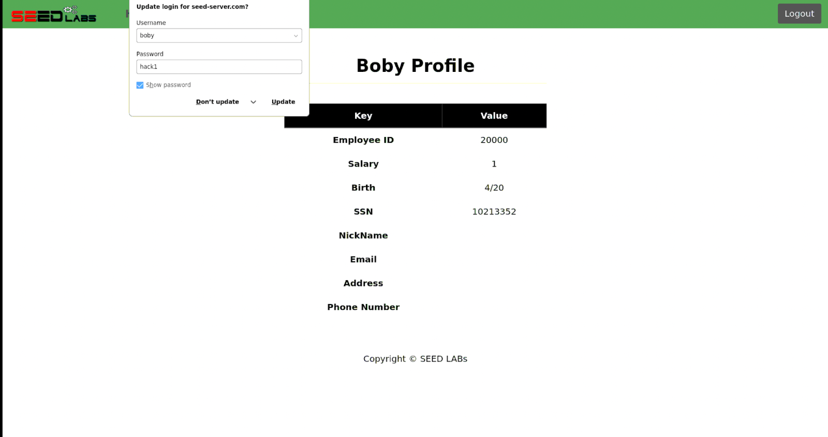

We were successfully able to log in using our new password which indicates that Alice’s attack was successful. We can also view Boby’s updated salary from the previous attacks. Now Alice can cause further damage since she has full access to her boss’s account.

**Task 4: Countermeasure — Prepared Statement**

In this task, we will use the prepared statement mechanism to fix the SQL injection vulnerabilities. For the sake of simplicity, we created a simplified program inside the defense folder. We will make changes to the files in this folder. If you point your browser to the following URL, you will see a page similar to the login page of the web application. This page allows you to query an employee’s information, but you need to provide the correct username and password.

For this section of the lab, we want to test the countermeasures so an attack like this can be defended against. Since we know the database and the web server are connected through the source code, we need to make some changes to that to get started. We open the unsafe.php file to modify the source code to fix the vulnerability. We can do this by going into the directory for the defense folder. We see source files and among them is unsafe.php.

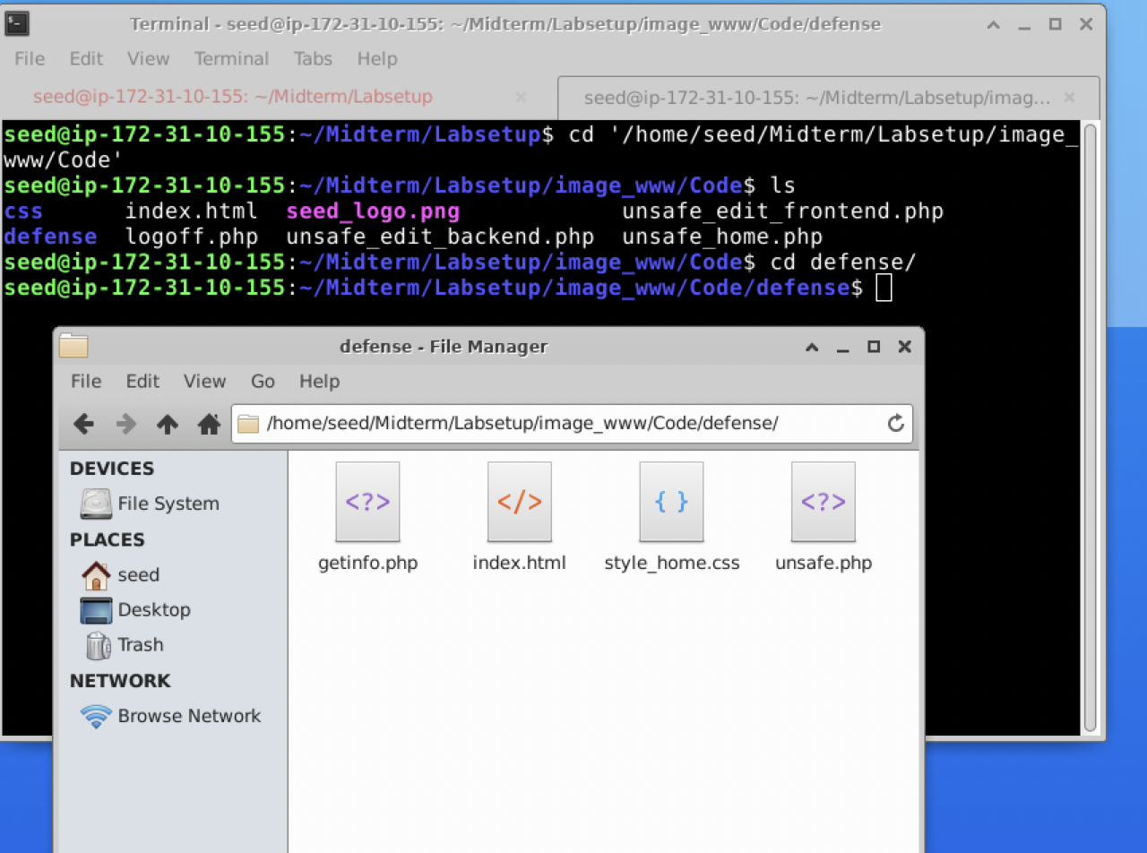

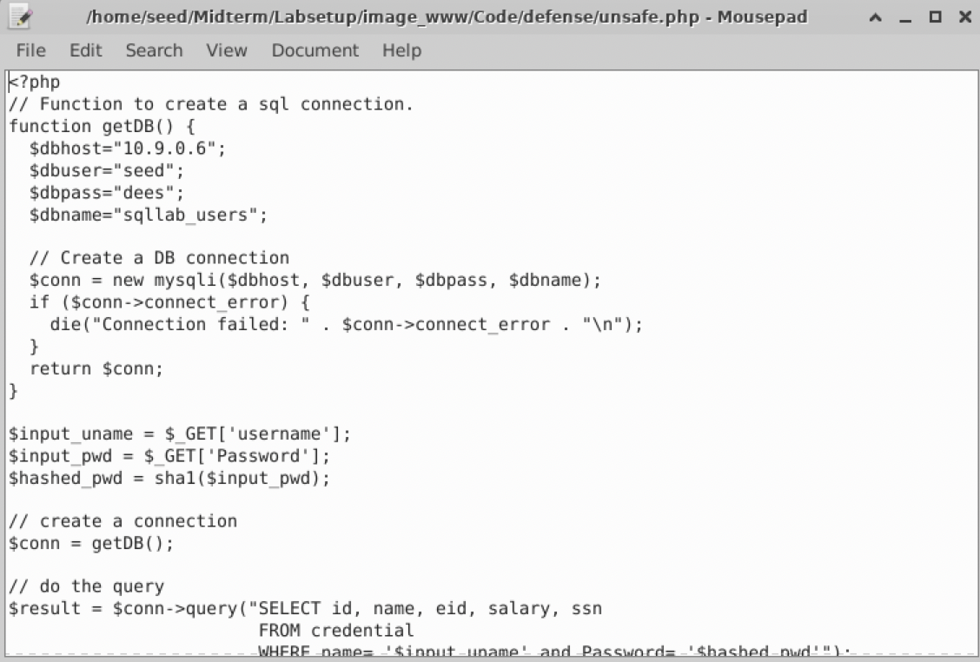

First thing we want to do is comment out lines 26-27 since the code is vulnerable to SQL injection attacks.

$stmt = $conn->prepare("SELECT id, name, eid, salary, ssn

                        FROM credential

                        WHERE name= '$input_uname' and Password= '$hashed_pwd'");

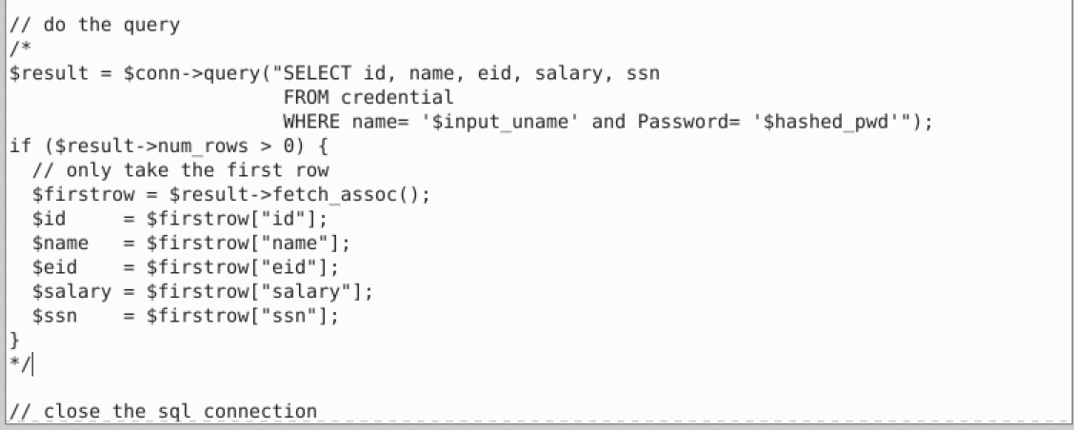

We want to update the code and rewrite it as the following given to us in the lab instructions.

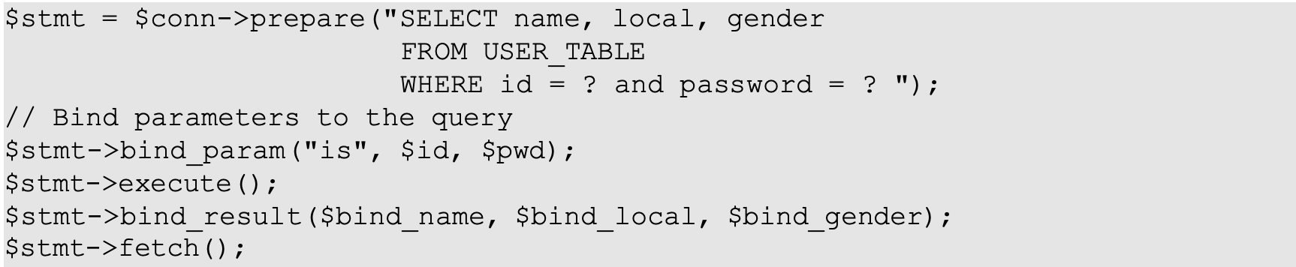

We want to change the template given to us to statements that would defend against vulnerabilities. Instead of the local and gender from the template, we replace with the values and credentials from the database.

Once we fill in the code from the values of the source code, it should look like this. We make a connection to the statement to access the credentials of the employees and imbed binding parameters to the query.

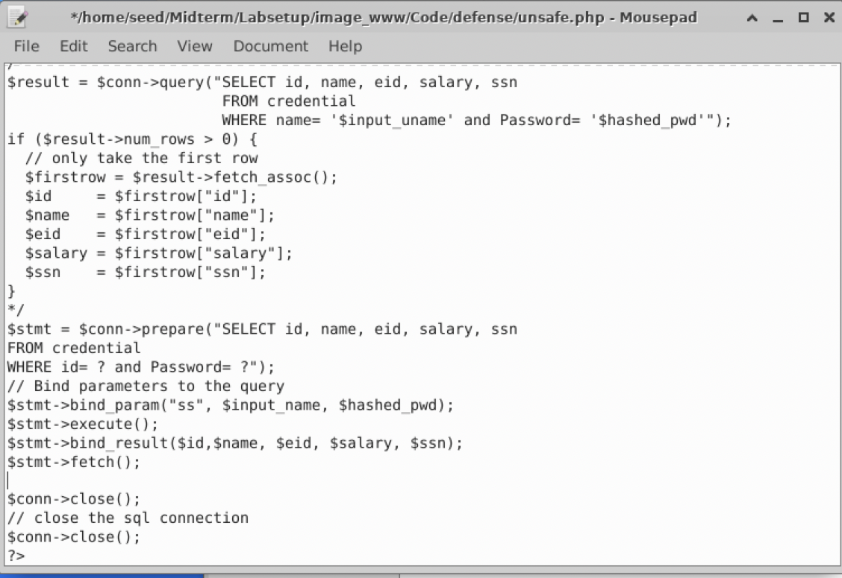

Now, we want to save our changes by running these commands.

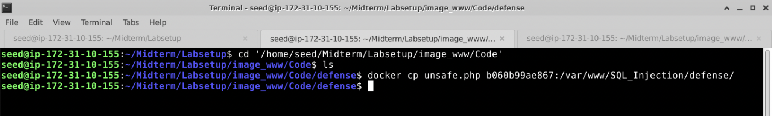

This copies the changes of the source code to the container of the defense folder.

Now, the next step is to test our defense against the SQL Injection attacks.

We will use the following website to see the information that is returned from the database.

URL: <http://www.seed-server.com/defense/>

We log into Boby’s account, and we use the password that we set from the previous task to get the information for his account. Once we log in, we see the following information returned for Boby’s account. When we log in normally, we see that the information is being returned from the database.

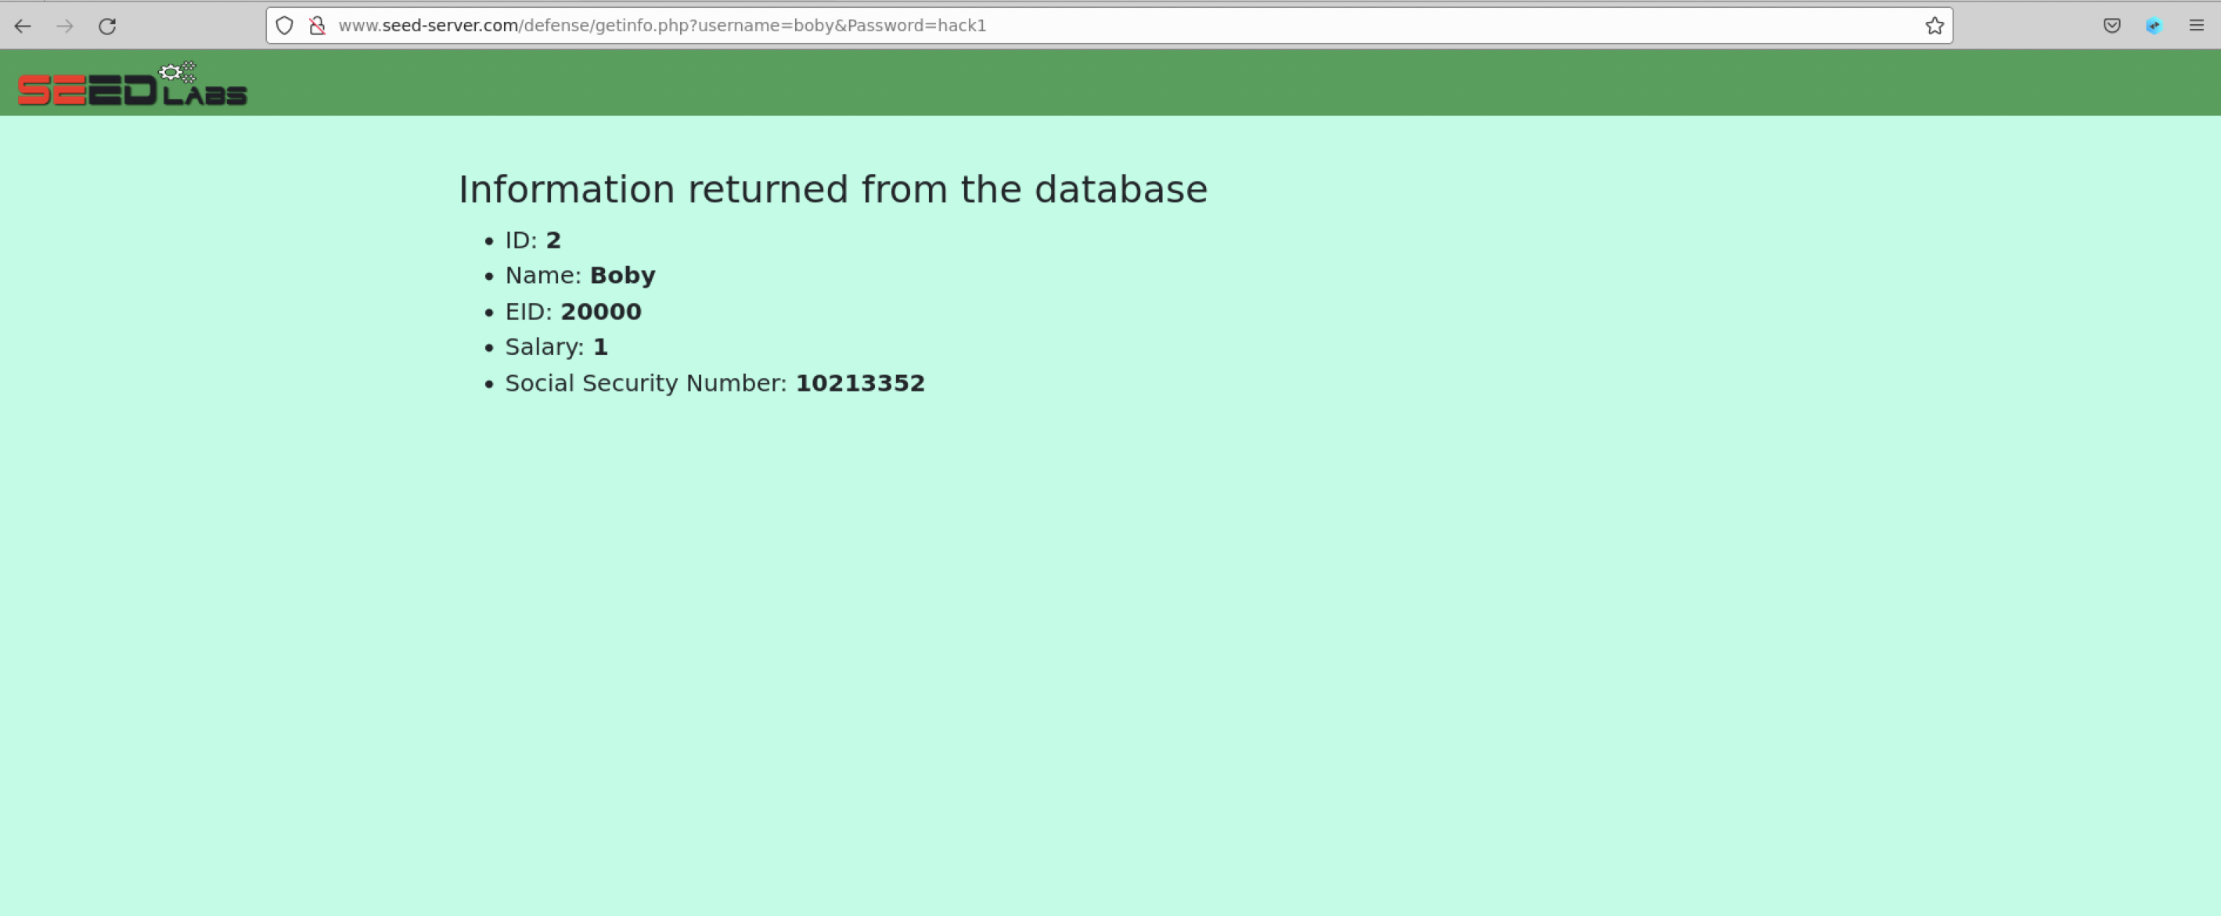

We see that the information from the database is returned for Boby’s account as well as the salary change that we modified from the previous labs.

Now, we want to check the information after the countermeasure takes place

We test to see whether the attack would work if Boby’s information were attempted to being accessed without a password. The ’ # is used to comment out conditions and allows to login without a password. Otherwise, any user can login using their password and they will see their own account information being returned. We want to see if an anonymous person trying to enter in a vicim’s account without a password can retain the same information as someone with the password access.

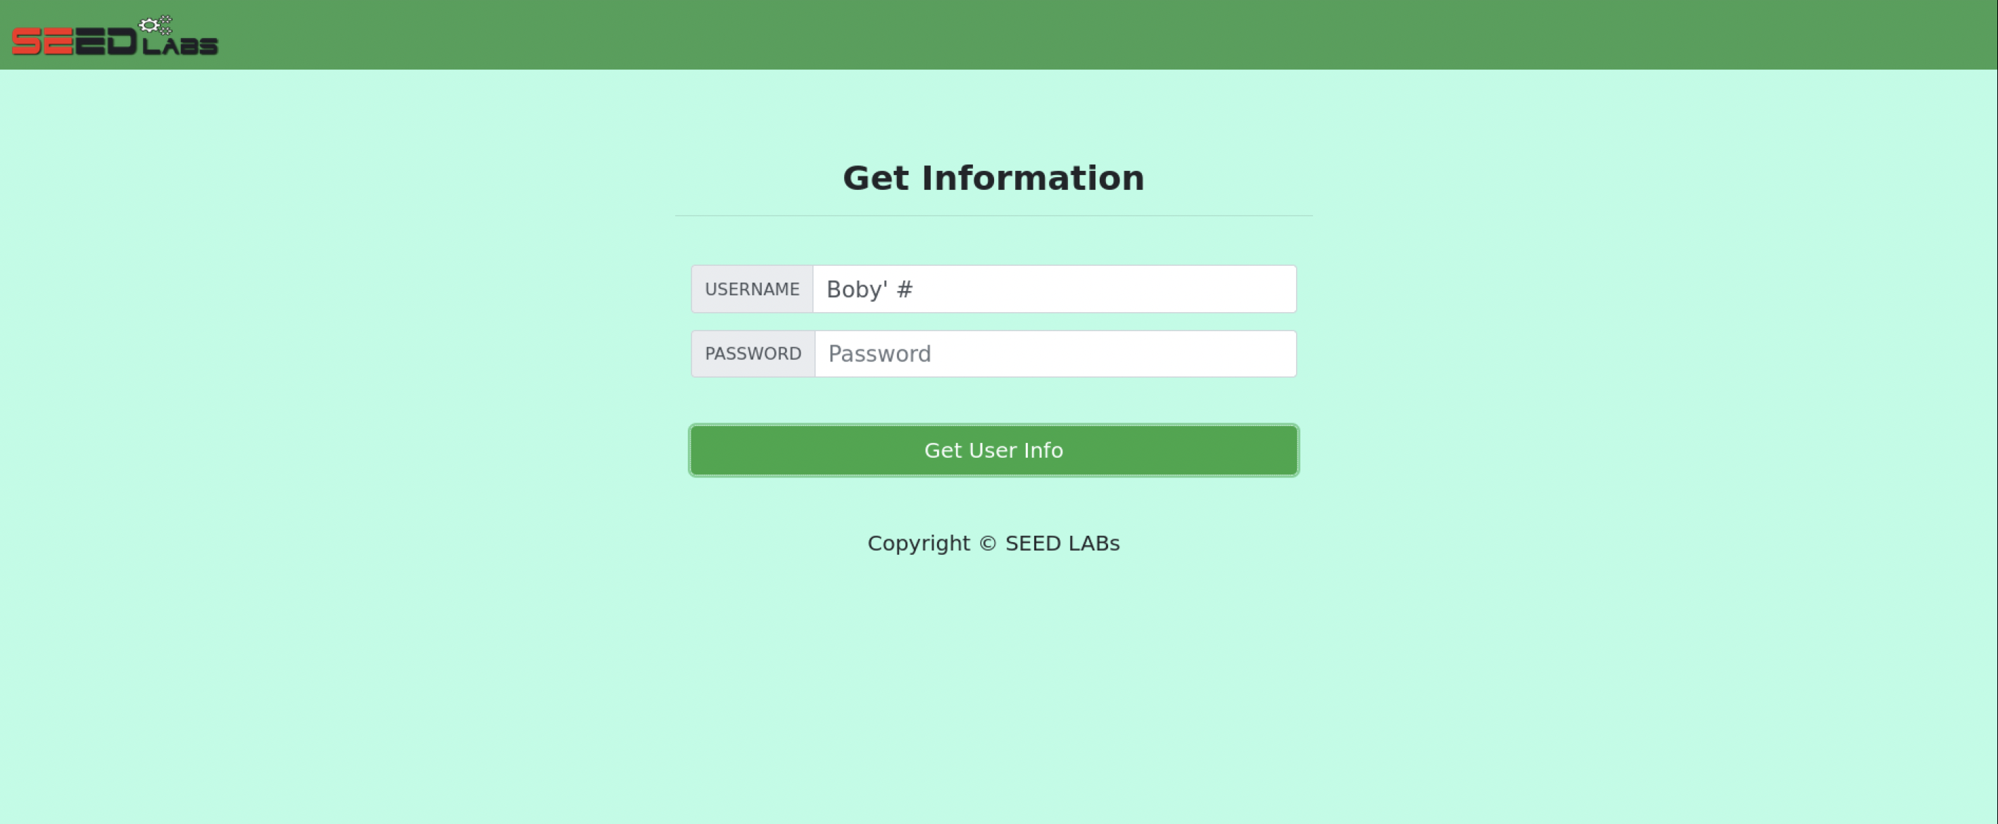



We see that the attack was unsuccessful because of the countermeasure that was in place. We see that there is no information that is returned from the database which indicates that a hacker cannot proceed to run attacks to gather and change information in the database using the victim’s credentials and query statements in the text fields. This shows that the countermeasure was successful in defending against SQL Injection attacks.

|  |  |  |  |
| --- | --- | --- | --- |
| Team member | Major Contribution | Assistance to others | Comments |
| Qumber Zaidi | Team Leader, worked and wrote lab reports on tasks 3 and 4. Completed questions 7-12 for the questions part of the lab. | Assisted team members on understanding each task step by step by comparing lab results and gathering work from the whole team to keep work intact. |  |
| Ali Abbas | Worked and wrote lab report on tasks 1 and 2. Completed questions 1-6. | Assisted to solve questions and tasks with team as they went through it. |  |